AI BASED EXERCISE RECOMMENDATION SYSTEM

HARISH K   
 Department of Information Technology  
Sri Sivasubramaniya Nadar College of EngineeringTamil Nadu  
[harish2110653@ssn.edu.in](mailto:harish2110653@ssn.edu.in)

Dr.N. Radha

Department of Information Technology

Sri Sivasubramaniya Nadar College of Engineering

Tamil Nadu

HARISH RM  
Department of Information Technology  
Sri Sivasubramaniya Nadar College of EngineeringTamil Nadu  
harish2110591@ssn.edu.in

Dr.R.Swathika

Department of Information Technology

Sri Sivasubramaniya Nadar College of Engineering

Tamil Nadu

Abstract**—**The escalating prevalence of sedentary lifestyles and associated health issues worldwide has prompted an urgent need for effective strategies to promote physical activity. Regular exercise is a cornerstone of preventive healthcare, yet the one-size-fits-all approach to exercise recommendations often falls short in addressing the diverse needs and preferences of individuals. This research paper delves into the integration of Artificial Intelligence (AI) into healthcare, specifically exploring the development of a sophisticated AI-based physical exercise recommendation system. By leveraging machine learning algorithms, this system aims to provide personalized exercise plans, taking into account individual health profiles, preferences, and constraints. The paper not only reviews existing literature on AI applications in health but also presents a novel methodology to enhance the precision and effectiveness of personalized exercise recommendations.

***Keywords—AI, Genetic, CSP, workout, exercise, recommendation, health, fitness;***

# Introduction

In an age characterized by technology-driven convenience, we often find ourselves grappling with the paradox of modern life: while our daily routines become increasingly sedentary, the importance of regular physical exercise for our health and well-being remains as paramount as ever. For many individuals, the prospect of embarking on a fitness journey can be a daunting and perplexing endeavor. The abundance of exercise options, coupled with varying fitness goals and unique medical conditions, presents a complex puzzle that can be challenging to solve.

The answer to this challenge lies at the intersection of artificial intelligence (AI) and knowledge representation systems, offering a web-based exercise recommendation system that is both personalized and intelligent. This project seeks to create a dynamic and adaptable platform that leverages cutting-edge AI algorithms and a comprehensive knowledge graph, empowering individuals to embark on fitness journeys tailored to their specific needs and preferences.

The vision for this project is rooted in the belief that technology can be harnessed to promote healthier, more active lives. By democratizing access to personalized exercise recommendations, we aspire to motivate individuals to embrace physical activity, thereby contributing to a society that is not only more informed about fitness but also more committed to a healthier future.

As the world continues to recognize the importance of health and well-being, the development of this web-based exercise recommendation system represents a significant step towards ensuring that individuals are equipped with the knowledge and guidance to take charge of their fitness journeys. It's a convergence of technology and wellness, designed to inspire and empower, and it promises to revolutionize the way we approach exercise and well-being in the digital age.

In an age where convenience and technology have become integral parts of our lives, the paradox of modern living is strikingly evident. On one hand, we are empowered by the limitless possibilities of digital innovation, making our lives more comfortable and efficient. Yet, on the other hand, our routines have become increasingly sedentary, leading to a concerning rise in health issues, most notably obesity and its related complications. It is no secret that regular physical exercise remains one of the most effective and proven methods to combat these health challenges. However, a stark dilemma persists - as the importance of exercise has grown, so too has the complexity of embarking on a fitness journey.

For many, the task of selecting an appropriate exercise routine can be a bewildering journey into the unknown. The sheer number of exercise options, the myriad of fitness goals, and the diverse medical conditions that individuals may face present a challenging puzzle to solve. Moreover, as the world grows more interconnected and digitized, a deluge of information on health and fitness inundated us daily, often causing more confusion than clarity. This conundrum begs the question: How can we harness the very technology that both simplifies and complicates our lives to make informed choices about our physical well-being?

The motivation behind this project is deeply rooted in the recognition of this pressing need for personalized and intelligent exercise recommendations. It's about breaking through the complexity and confusion surrounding fitness choices, empowering individuals to embark on tailored, sustainable, and safe fitness journeys. This project seeks to provide a holistic solution that bridges the gap between our innate desire for a healthier lifestyle and the vast landscape of exercise possibilities.

In conclusion, the motivation behind this project is deeply rooted in the desire to address a pressing need for personalized, intelligent, and data-driven exercise recommendations in the digital age. It's about enabling individuals to embrace physical activity with confidence and commitment. It's about making health choices less daunting and more empowering. It's about leveraging technology to steer us towards a future where health and fitness are not burdens but joys, where each step taken is a step toward a healthier, happier life.

The importance of this initiative cannot be overstated. It's a response to the challenges of our times, a bridge between the complexities of fitness and the simplicity of technology, and a call to empower individuals to take control of their health and well-being in a world that is increasingly characterized by both opportunities and challenges.

CONTENT:

The research paper introduces an AI-based exercise recommendation system to tackle the global health challenges arising from sedentary lifestyles. By leveraging machine learning algorithms, including genetic algorithms and Constraint Satisfaction Problem (CSP), the system aims to offer personalized workout plans. The methodology involves in-depth user data analysis, optimization through genetic algorithms, and exercise selection using CSP. Results demonstrate the system's ability to suggest exercises meeting user constraints and evolving workout plans based on calorie expenditure. The user interface and output exemplify the practical implementation of the proposed system, underscoring the potential of AI in shaping a future focused on preventive healthcare and individualized wellness.his paper:

# RELATED WORKS

The comprehensive literature survey commences with an in-depth examination of existing AI-based health applications, encompassing those dedicated to physical activity monitoring and exercise recommendations. Pivotal studies such as [1]and [2] offer valuable insights into the contemporary state of AI applications within the health and fitness domain. These works underscore the potential of AI in deciphering user behaviour, preferences, and health conditions, emphasizing the imperative for personalized exercise plans.

Moreover, the exploration extends to research such as [3]**,** shedding light on the integration of context-awareness in health applications. Context-awareness becomes paramount for a physical exercise recommendation system as it takes into consideration environmental factors, user mood, and other situational parameters to tailor exercise routines optimally.

In [4]**,**This document discusses the development of a recommendation system for exercise goals that have a high probability of success. The approach involves using embedding algorithms, specifically SkipGram, to convert exercise names into vector representations. The system takes into account the perceived difficulty of goals for each individual, based on their history and self-efficacy. The goal is to recommend exercises that are challenging enough to be motivating but still achievable. The system combines association rules and recurrent neural networks to make personalized recommendations. The effectiveness of the system is evaluated using simulations and comparisons to a computational cognitive model.

In[5],This paper proposes a system for personalized fitness assistants using gamification and continuous player modelling and reported on a long-term study that investigates the effectiveness of the proposed system. The findings show that it is possible to provide personalized activity recommendations by continuously updating a player model based on activity tracking through some wearable device. Their study also shows the positive effect of this modeling and gamification on user engagement and overall activity. These findings can be used to inform the design of personalized and gamified recommender systems in health and fitness and potentially other apps, as they highlight the role of an adaptive model and gamification as long-term and short-term factors, respectively.

In[6]**,**This document discusses the importance of exercise in preventing and treating chronic diseases. It highlights the use of exercise recommendation systems and personalized exercise prescriptions to guide individuals towards effective exercise programs. The document mentions the integration of various recommendation techniques, such as collaborative filtering and content-based approaches, in healthcare recommendation systems. It also mentions the use of AI-driven interventions for diagnosis, risk assessment, disease prediction, and health policy planning. The document describes the data preprocessing steps, including the averaging of rest heart rate and exercise data, to represent monthly values for each user. The construction of the exercise prescription system is based on data from a sports-based social platform. Overall, the document emphasizes the significance of exercise in improving health outcomes and the role of recommendation systems in guiding individuals towards appropriate exercise routines.

In [7],This paper proposes a novel approach (KCP-ER) for exercise recommendation by considering the prediction of knowledge concepts. To obtain a good embedding of exercise content, which is beneficial for making recommendations for the students, we first build a LSTM-based module for the prediction of the knowledge concept coverage prediction, and a Deep Knowledge Tracing module for the prediction of the knowledge concept mastery.

In [8],This paper proposes a recommender system (RS) to support the fitness assistance system (F AS) with artificial intelligence. The RS is applied to make these suggestions for the beginners and existing users. The goal of the paper aims to develop an RS that has an ability to learn, analyse, predict, and make these suggestions as well as communicate to human through AI. Artificial Neural Network and Logistic Regression have been employed to predict the suitable workout for each beginner. In addition, the agent developed with reinforcement learning capability of Soar architecture help the members select their workout based on their condition. Through the experimental result, the effectiveness of utility application is

In [9], The research paper addresses the significant issue of low back pain, a prevalent musculoskeletal condition that constitutes a leading cause of disability globally, with considerable socioeconomic implications. Traditional methods of assessing muscle status in low back pain rehabilitation, specifically endurance tests, face practical limitations that may result in inaccurate diagnoses. To overcome these challenges, the paper introduces mDurance, a novel mobile health system designed to enhance the functional assessment of trunk endurance through the utilization of wearable and mobile technologies. The system employs a wearable inertial sensor to monitor patient trunk posture and portable electromyography sensors to measure electrical activity in trunk muscles. A mobile application processes and manages the data collected, streamlining the expert's routine, reducing human errors, and expediting test result analysis. The paper highlights the reliability of mDurance through a case study, demonstrating practitioner interest in integrating such a system into regular use for improved low back pain assessment.

In [10], The research paper describes the development of a comprehensive mobile application named the ADAPTATION & PERSONALIZED FITNESS APP. The application offers three main modules catering to users' fitness needs. Firstly, the Exercise section provides users with the flexibility to engage in workouts at their preferred locations, offering a variety of exercise types to promote a healthier lifestyle. Secondly, the Diet module enables users to track their food intake and make informed dietary choices by examining statistics related to their bodies. Lastly, the app incorporates a Yoga section for users to practice yoga in the comfort of their homes. The primary goal of these modules is to assist users in preventing serious illnesses, fostering a healthier life that can be enjoyed with their loved ones. The paper mentions the use of the life cycle model of repetition and multiplication to assess feasibility, indicating that the project will undergo cycles of needs assessment, design, implementation, and continuous feature enhancements, similar to the iterative process observed in fitness apps like Runtastic Running & Fitness.

In [11], The paper highlights the growing significance of Big Data in healthcare, bioinformatics, and information sciences, indicating a 44-fold increase in data production since 2009. The surge in data volume, velocity, and variety poses challenges in storage, processing, and visualization using traditional technologies. While major social networking platforms like Twitter, LinkedIn, and Facebook leverage big data for various use cases, there is a noticeable gap in the conceptual architecture for specific big data applications. The paper aims to address this gap by proposing an application-oriented architecture for big data systems, informed by a study of published architectures tailored for specific use cases. Additionally, the paper delves into the state-of-the-art machine learning algorithms, particularly in the healthcare sector, offering insights into their application for processing vast datasets. The research seeks to contribute to the understanding and development of effective big data architectures, emphasizing real-world applications and the integration of advanced machine learning techniques.

In [12], The research paper focuses on the intersection of health, fitness, and technology to address the importance of proper exercise execution for maintaining overall well-being. The proposed system employs a novel approach by utilizing a body movement tracking system, specifically the Mediapipe Pose Estimation Model, to monitor and quantify exercise repetitions. This technology not only counts repetitions but also ensures that exercises are performed within the prescribed model guidelines to prevent adverse effects on the body. In addition to tracking body movements, the system provides audio instructions to guide users in performing exercises correctly. Notably, the system integrates user-specific data, including physical measurements and dietary information, to monitor calorie intake. By leveraging this personalized information, the system recommends a specific calorie intake tailored to achieve a normal Body Mass Index (BMI) for optimal fitness. The holistic nature of this approach encompasses exercise monitoring, guidance, and dietary advice, making it a comprehensive tool for individuals striving to maintain a healthy lifestyle.

In [13], This research paper presents the first bibliometric study aimed at systematically mapping the evolving field of fitness applications, which has witnessed significant development and popularity in both academic and practical domains. The study analyzes 481 records from the Scopus and Web of Science databases, spanning the years 2011 to 2019. Through various bibliometric analysis methods, including statistical analysis and science mapping, the authors investigate key aspects such as the year of publication, journal names, citations, authors, countries, and research methodologies. Utilizing the VOSViewer software, co-authorship, co-citation of authors, and co-occurrence of keywords are mapped, shedding light on the interdisciplinary nature of the field.

In [14],The paper highlights the underutilized potential of metaheuristic algorithms, specifically the genetic algorithm, in medical research and decision-making. Unlike classical statistical methods, these algorithms offer optimal or near-optimal solutions to complex medical problems within a reasonable timeframe. The paper emphasizes that while metaheuristic algorithms have found success in various scientific fields, their application in medicine remains largely unknown to physicians. The objective of the research is to introduce the genetic algorithm and shed light on its promising applications across numerous medical specialties, including radiology, oncology, cardiology, surgery, and more. The review outlines potential applications in disease screening, diagnosis, treatment planning, pharmacovigilance, prognosis, and health care management. By familiarizing physicians with the versatility of the genetic algorithm, the paper aims to encourage its adoption as a valuable tool for addressing intricate medical challenges, ultimately enhancing healthcare practices and outcomes.

In [15], The paper highlights the significant global impact of cancer, the second leading cause of death, and emphasizes the importance of effective screening, early diagnosis, and recurrence prediction for successful treatment. Acknowledging the challenges posed by expensive and invasive tests, the abstract introduces the potential of Genetic Algorithms (GAs), a type of evolutionary algorithm, in addressing these issues. GAs are recognized for their ability to navigate complex search spaces and find optimal or near-optimal solutions, making them particularly suitable for creating models that interpret test results, with a focus on noninvasive approaches.

# METHODOLOGY

The proposed AI-based physical exercise recommendation system employs cutting-edge machine learning algorithms to meticulously analyse user data, thereby generating bespoke exercise plans. The system factors in an array of input parameters, including user health data (e.g., heart rate, blood pressure, and existing medical conditions), preferences (e.g., preferred types of exercises, duration, and intensity), and constraints (e.g., time availability and access to specific equipment).

The machine learning model undergoes rigorous training on a diverse dataset, encompassing a spectrum of user profiles and health conditions. The model learns to discern correlations between different user attributes and the effectiveness of various exercise routines. The system incorporates a dynamic recommendation engine that adapts continually based on user feedback and changes in health status.

Furthermore, the paper accentuates the significance of explainability and transparency in AI-based health applications, ensuring that users comprehend the rationale behind the exercise recommendations. This fosters trust and heightens user compliance, critical elements for the success of any health-related AI application.

The proposed system's methodology goes beyond conventional exercise recommendation models by integrating predictive analytics, enabling the system to anticipate user needs and adapt recommendations proactively. The use of predictive analytics enhances the system's ability to cater to evolving user preferences and dynamically adjust to changes in health conditions.

The system begins with the collection of user data, including personal details, fitness goals, historical exercise data, and constraints such as available time, equipment, and preferences.The integration of genetic algorithms in fitness planning has shown promise in optimizing workout routines.

Genetic Algorithm

Personalised exercise routines are created by this genetic algorithm according to the user's desired push-up count and fitness level. The programme outlines a variety of workouts for various muscle groups and skill levels. The individual generation, fitness calculation, crossover, and mutation processes are among the functions that the genetic algorithm uses to carry out its operations. Based on the user's degree of fitness, the generate_individual function generates a workout plan for each category, and the calculate_fitness function assesses the total fitness of an individual plan. Subsequently, the computer chooses parents according to their fitness scores, combines their qualities through crossover, and adds mutations to preserve diversity. Iterations of the procedure take place across several generations. In order to prevent duplicate fitness scores on consecutive days and provide variation in the created training routines, the main loop runs the evolutionary algorithm for a certain number of days. Together with pertinent information like fitness scores, calorie burn estimations, and the relative contributions of each exercise to total fitness, the final product offers the optimal workout schedule for every day. All things considered, this genetic algorithm provides a flexible and dynamic way to design efficient training regimens that are customized to each person's fitness levels and goals.

Exercise Definitions:

Exercises for each category are defined with attributes such as name, difficulty level, duration/repetitions, and target quantity.

Categories include Chest, Abs, Legs, Arms, and Back.

Parameters:

population_size: Number of individuals in each generation.

num_generations: Number of generations for the genetic algorithm.

num_days: Number of days for which workout plans are generated.

level: Fitness level (Beginner, Intermediate, Advanced).

pushup: Target number of push-ups.

Functions:

generate_individual(level): Generates an individual workout plan based on the fitness level.

calculate_fitness(individual): Calculates the fitness score of an individual based on the total workload.

calculate_fitness_individual(individual): Calculates the fitness contribution of each exercise in an individual's plan.

crossover(parent1, parent2): Performs crossover between two parents to create a child.

mutate(individual): Introduces random mutations in an individual's plan.

Genetic Algorithm Execution:

Initializes a population of workout plans.Evaluates the fitness of each individual in the population.Selects parents based on fitness scores.Performs crossover and mutation to generate a new population.Repeats the process for a specified number of generations.

Main Loop:

Iterates over a specified number of days.

Calls the genetic algorithm to obtain the best workout plan for each day.

Ensures that duplicate fitness scores are not considered on consecutive days.

Prints the workout plan, fitness score, calorie burn estimates, and individual exercise contributions.

#### Optimization and Customization:

The code allows customization of the number of generations, population size, fitness level, and target push-ups.

Adjustments to the mutation rate and selection criteria can be made to influence the diversity and convergence of the population.

#### Outputs:

The final output provides the best workout plan for each day, along with fitness scores, calorie burn estimates, and individual exercise contributions.

CSP:

Function Definition:

Define a function calculate_best_exercise that takes parameters: equipment, duration, intensity, calories, target_muscle, i (current index), and variables (result list).

Base Case:

If the current index i is greater than or equal to the length of the exercise domain, return the list of variables.

Exercise Selection:

Get current exercise from the domain based on the index i.

Criterion Check:

Check if the current exercise satisfies all criteria:

Equipment is present in the exercise's equipment list.

Duration is within the specified range.

Calories burned are within the specified range.

Intensity is within the specified range.

Target muscle is in the exercise's targeted muscles.

Result Update:

If the exercise satisfies all criteria, add a pair [index + 1, exercise] to the variables list.

Recursion:

Recursively call the function with an incremented index to consider the next exercise

.

Example Usage:

Demonstrate the usage of the function with specific criteria ("dumbbells", 30, 5, 250, "legs")

.

Result Display:

Print or use the result obtained from the function.

## *Workflow*

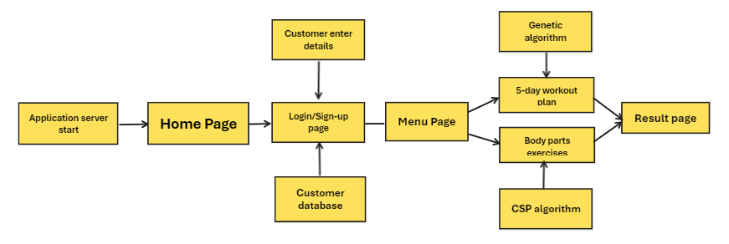

The work plan for the AI-based workout recommendation system project encompasses several pivotal stages. After initiating the project and defining its scope, the team proceeds to user research to understand preferences and constraints. The algorithm selection and design phase focus on incorporating both genetic and Constraint Satisfaction Problem (CSP) algorithms into the system architecture. Subsequent development phases, including prototype development and algorithm implementation, prioritize the integration of genetic and CSP algorithms to enhance the recommendation mechanisms. The work plan emphasizes continuous refinement through user testing and feedback loops, ensuring the system's responsiveness to individual fitness needs. Throughout the process, the plan maintains flexibility to adapt to user insights, culminating in the deployment of a robust and adaptive AI-powered workout recommendation system.

# RESULTS AND DISCUSSION

Exercise Recommendation with Constraint Satisfaction Problem:

TABLE 1.1

| RANK | Constraints Satisfied | EXERCISE NAME |
| --- | --- | --- |
| 1. | 4 | WEIGHTLIFTING |
| 2. | 4 | RESISTANCE BAND ROWS WITH DUMBBELLS |
| 3. | 2 | DUMBELL LUNGES |

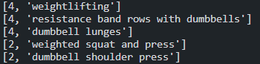

The exercise with the most constraint satisfied is the best exercise for the given input which includes equipment, body part, body part, time, difficulty, calories to burn.

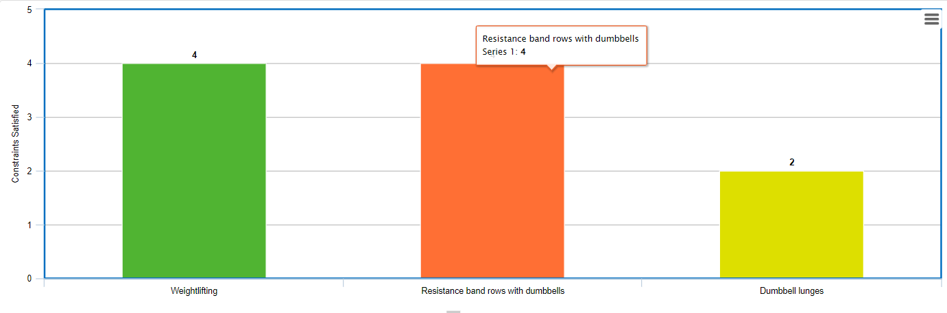

Based on the CSP Algorithm, the graph shows that the system suggests workouts that meet the majority of the user-given restrictions. This methodology is used as a validation tool to assess the system's output, which explains its accuracy and correctness..

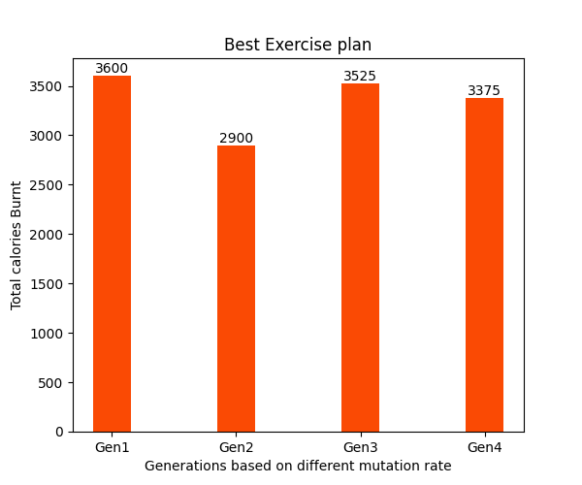

The graph above illustrates how a genetic algorithm is used to generate different generations of workouts. The optimal generation is then selected and suggested to the user based on how many calories are expended overall when performing the provided set of exercises. Additionally, the system is assessed and tested using a variety of other inputs. One such system evaluation is shown in the graph above.

.

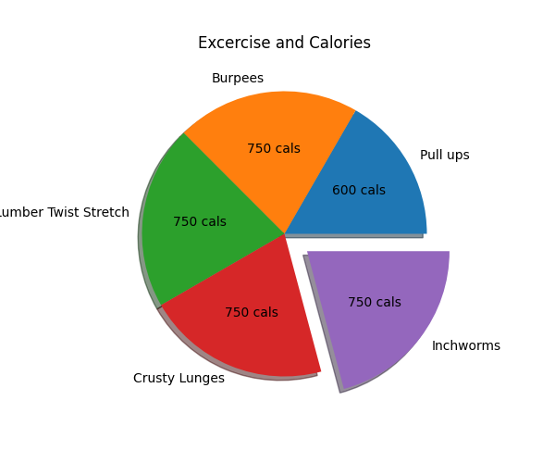

The pie chart above provides an overview of workouts and their effects on health, as well as an illustration of the relative contributions of each exercise and how many calories each one burns. This procedure is also tested with a variety of additional inputs.

The outputs of the application such as application interface, user forms and results page have been shown below

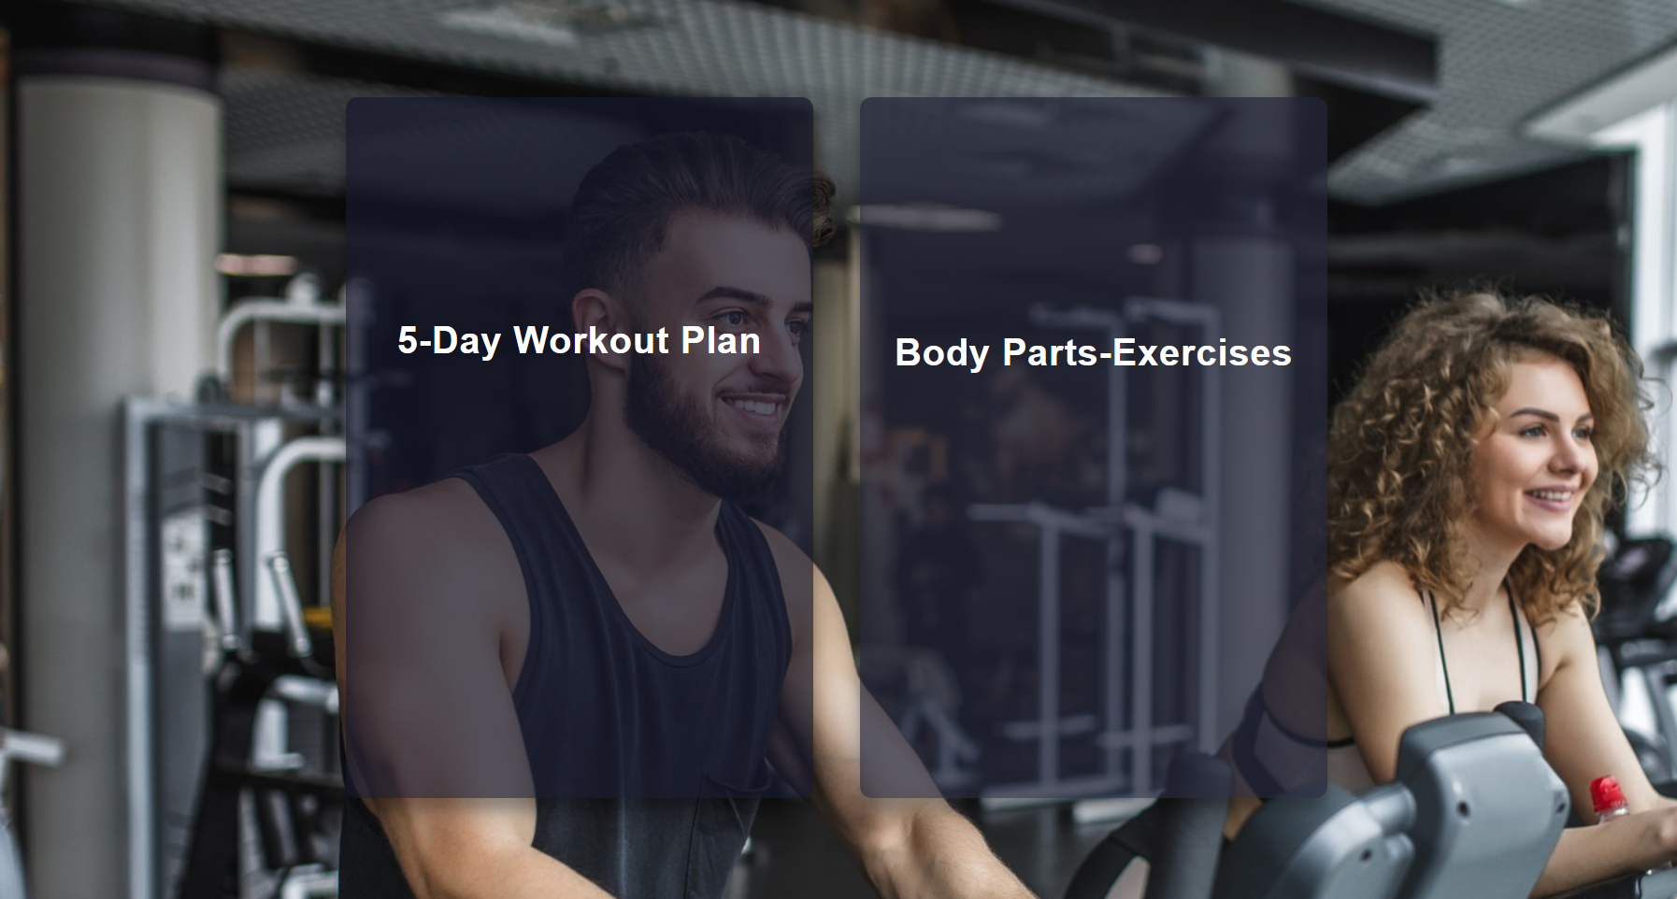

The above picture represent application interface which makes it comfortable for the user to use and interact with our application. below are the outputs of the application

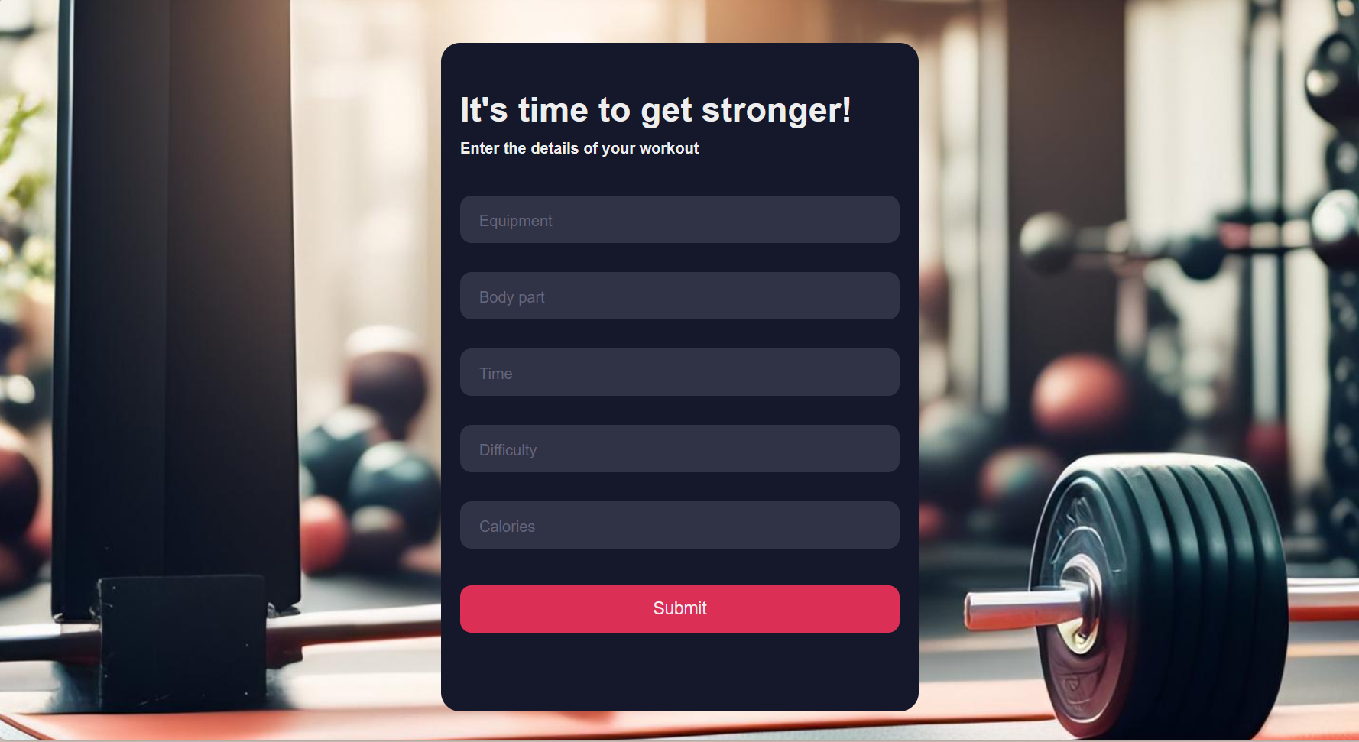

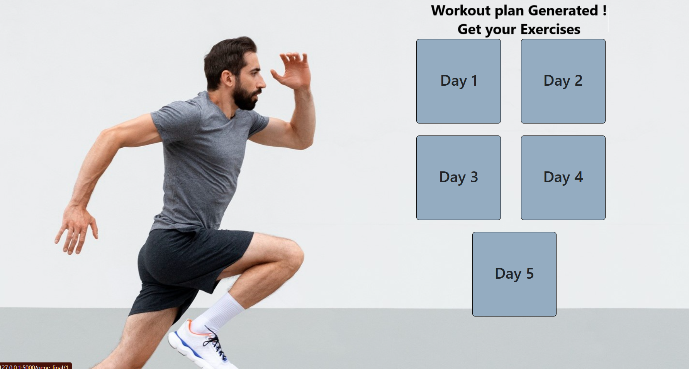

This is the five day workout plan suggested by using genetic algorithm

##### 

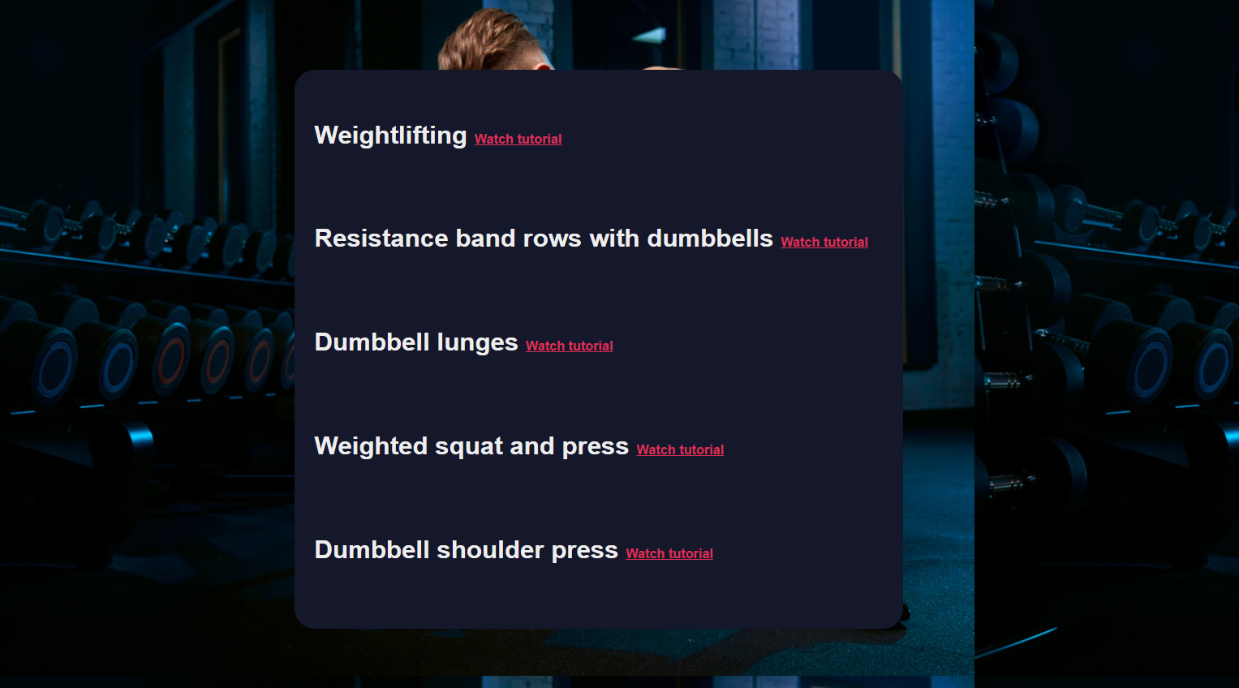

The above is the result of the CSP algorithm which provides the best exercise to do now.

The above screenshots represent the output or the results of the user’s recommendation based on their inputs through the forms collected through our application during the process of recommendation.

##### V.CONCLUSION

This research paper not only provides a comprehensive overview of the current state of AI-based physical exercise recommendation systems but also introduces a pioneering methodology to address the limitations of generic exercise plans. By synthesizing insights from existing literature and proposing a novel approach, the paper contributes significantly to the growing body of knowledge at the intersection of AI and healthcare. The proposed system strives to elevate user engagement and adherence to exercise routines, ultimately promoting a healthier lifestyle.

Future research endeavours and empirical studies are recommended to validate the efficacy of the proposed system in real-world scenarios, ensuring its practicality and impact on public health. The continuous evolution of AI technologies offers exciting opportunities for further enhancements, such as integrating real-time physiological data and leveraging advanced neural networks to refine the accuracy of exercise recommendations.

The holistic approach presented in this paper sets the stage for a new era in personalized healthcare, where AI plays a pivotal role in promoting preventive measures and individualized wellness strategies. As the field of AI in healthcare continues to advance, the integration of such sophisticated systems holds the potential to revolutionize how we approach fitness, well-being, and disease prevention.

# FUTURE SCOPE

The future directions for this web-based exercise recommendation system revolve around the integration of advanced features to enhance user engagement and personalization. By incorporating real-time biometric data and wearable technology, the system can provide more accurate and dynamic recommendations, adapting to users' changing health statuses. The inclusion of social and community features fosters a sense of community and accountability among users, while continuous learning mechanisms ensure the platform stays current with the latest fitness standards and scientific findings. Additionally, exploring partnerships with healthcare professionals and expanding to specialized programs, such as rehabilitation exercises or sport-specific training, broadens the system's applicability and relevance to diverse user needs.

In terms of future scope, there is potential for the system to become more culturally adaptable and regionally relevant. By considering localized health guidelines and cultural fitness practices, the platform can resonate with a global audience. Advanced user profiling mechanisms and goal-setting features offer a more nuanced understanding of users' preferences and objectives, while collaborations with research institutions contribute to the scientific validity of the exercise recommendations. Overall, these future directions and scopes aim to elevate the system's impact by embracing technological advancements, fostering community engagement, and ensuring alignment with the evolving landscape of health and fitness.

##### References

[1] Zhang, S., McCullagh, P., Nugent, C., & Zheng, H. (2012). Personalized Physical Activity Recommendation: A Review. Journal of Medical Systems, 36(3), 1453–1464.

[2] Ronao, C. A., & Cho, S. B. (2016). A Survey of Artificial Intelligence Techniques in Physical Activity Recognition. Healthcare Informatics Research, 22(1), 6–29.

[3] Rashidi, P., & Mihailidis, A. (2013). A Survey on Ambient-Assisted Living Tools for Older Adults. IEEE Journal of Biomedical and Health Informatics, 17(3), 579–590.

[4] Physical Exercise Recommendation and Success Prediction Using Interconnected Recurrent Neural Networks by Arash Golibagh Mahyari and Peter Pirolli

[5] Effects of a Personalized Fitness Recommender System Using Gamification and Continuous Player Modeling: System Design and Long-Term Validation Study by Katherine Blondon and Enrica Loria

[6] An AI-Based Exercise Prescription Recommendation Systemby Hung-Kai Chen ,Fueng-Ho Chen  and  Shien-Fong Lin

[7] Exercise recommendation based on knowledge concept prediction by Zhengyang Wu , Ming Li , Yong Tang, Qingyu Liang

[8] Recommender System with Artificial Intelligence for Fitness Assistance System by Tin Trung Tran; Jae Won Choi; Chien Van Dang; Geon SuPark; Jun Young Baek; Jong Wook Kim

[9] Banos, O., et al. (2014). "mDurance: A Novel Mobile Health System to Support Trainers and Managers of Team Sports."

[10] Chen, Z., et al. (2017). "An Adaptive Personalized Fitness Plan Recommendation System."

[11] Yang, C., et al. (2017). "A Survey of Big Data Architectures and Machine Learning Algorithms in Healthcare."

[12] Gourangi Taware; Reena Kharat; Pratik Dhende; Prathamesh Jondhalekar; Rohit Agrawal. (2016) “AI-Based Workout Assistant and Fitness Guide”

[13] Status of the research in fitness apps: A bibliometric analysis Yali Liua and Maria Avellob.

[14] The Applications of Genetic Algorithms in Medicine

Ali Ghaheri, Saeed Shoar, Mohammad Naderan,and Sayed Shahabuddin Hoseini (2015)

[15] Cancer Detection and Prediction Using Genetic Algorithms Aradhita Bhandari,1B. K. Tripathy,1Khurram Jawad,2Surbhi Bhatia,3Mohammad Khalid Imam Rahmani,2and Arwa Mashat (2022)